**Create new users:**

* Start Jenkins and go to Manage Jenkins🡪 manage users🡪 create user

Give username and password .

**Configure new user:**

* Click on configure in drop down next to user with which we login and you can change various configurations from there.

**Create and manage user Roles:**

For creating and managing user roles we have role strategy plugin download it.

Now go to Jenkins_home folder and there we have plugins folder , now copy that downloaded hpi file inside this folder and restart your Jenkins.

Other way is go to Manage Jenkins🡪 manage plugins , from there you can install that plugin

**Now to use this plugin**:

Goto manage Jenkins🡪 configure global security 🡪select enable security ->select role based strategy then apply and save.

Go to manage Jenkins🡪 Manage and assign roles🡪 Manage Roles

Here we can create roles based on :

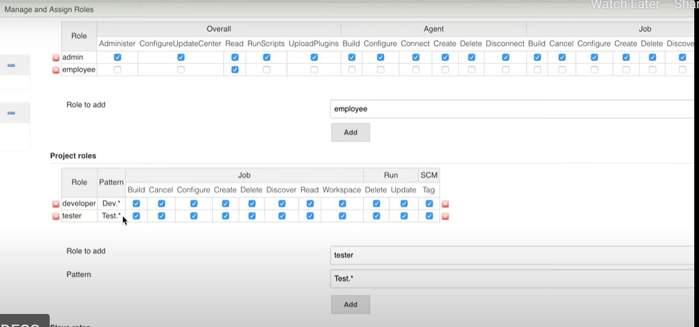

Now Apply and then save.

Now to assign above created roles to users go to

manage Jenkins🡪 Manage and assign roles Assign Roles

Assign global role as:

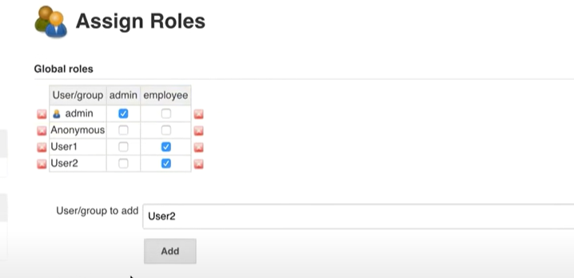

Assign project roles as:

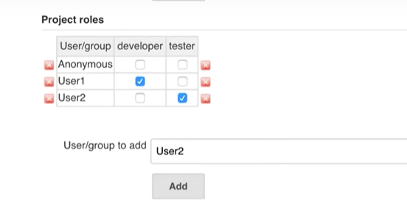

Now the user1 will be able to access the projects starting with dev and user2 can access projects starting with test.